Assembly Order

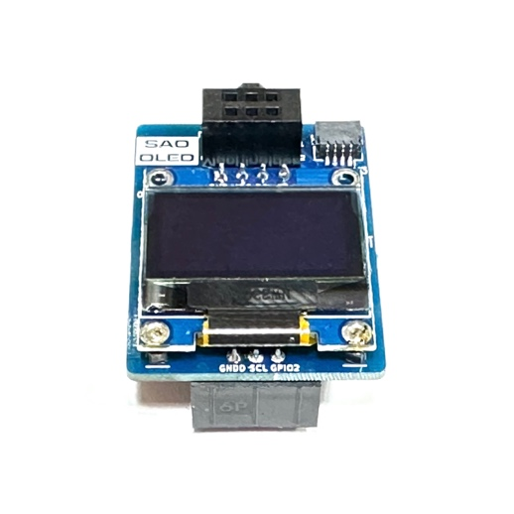

1. QWIIC

4. SAO Pins

5. OLED I2C PINS

6. Support

Pins on top

SAO OLED KIT V0.1

Assembly Order



1. QWIIC

4. SAO Pins

5. OLED I2C PINS

6. Support

Pins on top

SAO OLED KIT V0.1

Assembly Order



1. QWIIC

4. SAO Pins

5. OLED I2C PINS

6. Support

Pins on top

SAO OLED KIT V0.1

Assembly Order



1. QWIIC

4. SAO Pins

5. OLED I2C PINS

6. Support

Pins on top

SAO OLED KIT V0.1

Assembly Order



1. QWIIC

4. SAO Pins

5. OLED I2C PINS

6. Support

Pins on top

SAO OLED KIT V0.1

Assembly Order



1. QWIIC

4. SAO Pins

5. OLED I2C PINS

6. Support

Pins on top

SAO OLED KIT V0.1

Assembly Order



1. QWIIC

4. SAO Pins

5. OLED I2C PINS

6. Support

Pins on top

SAO OLED KIT V0.1

Assembly Order



1. QWIIC

4. SAO Pins

5. OLED I2C PINS

6. Support

Pins on top

SAO OLED KIT V0.1

Assembly Order



1. QWIIC

4. SAO Pins

5. OLED I2C PINS

6. Support

Pins on top

SAO OLED KIT V0.1

0x3C

0x3C

0x3C

0x3C

0x3C

0x3C

0x3C

0x3C

0x3C

7. Solder Jumper Power

7. Solder Jumper Power

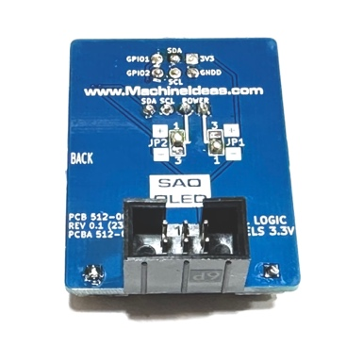

3. SAO Socket

2. Support

Pins on bottom



3. SAO Socket

2. Support

Pins on bottom

7. Solder Jumper Power



3. SAO Socket

2. Support

Pins on bottom



3. SAO Socket

2. Support

Pins on bottom



3. SAO Socket

2. Support

Pins on bottom



3. SAO Socket

2. Support

Pins on bottom



3. SAO Socket

2. Support

Pins on bottom



3. SAO Socket

2. Support

Pins on bottom



3. SAO Socket

2. Support

Pins on bottom

7. Solder Jumper Power

7. Solder Jumper Power

7. Solder Jumper Power

7. Solder Jumper Power

7. Solder Jumper Power

7. Solder Jumper Power